ASSIGNMENT - 6

ANIKEIT SETHI (190001003)

Ques 1: -

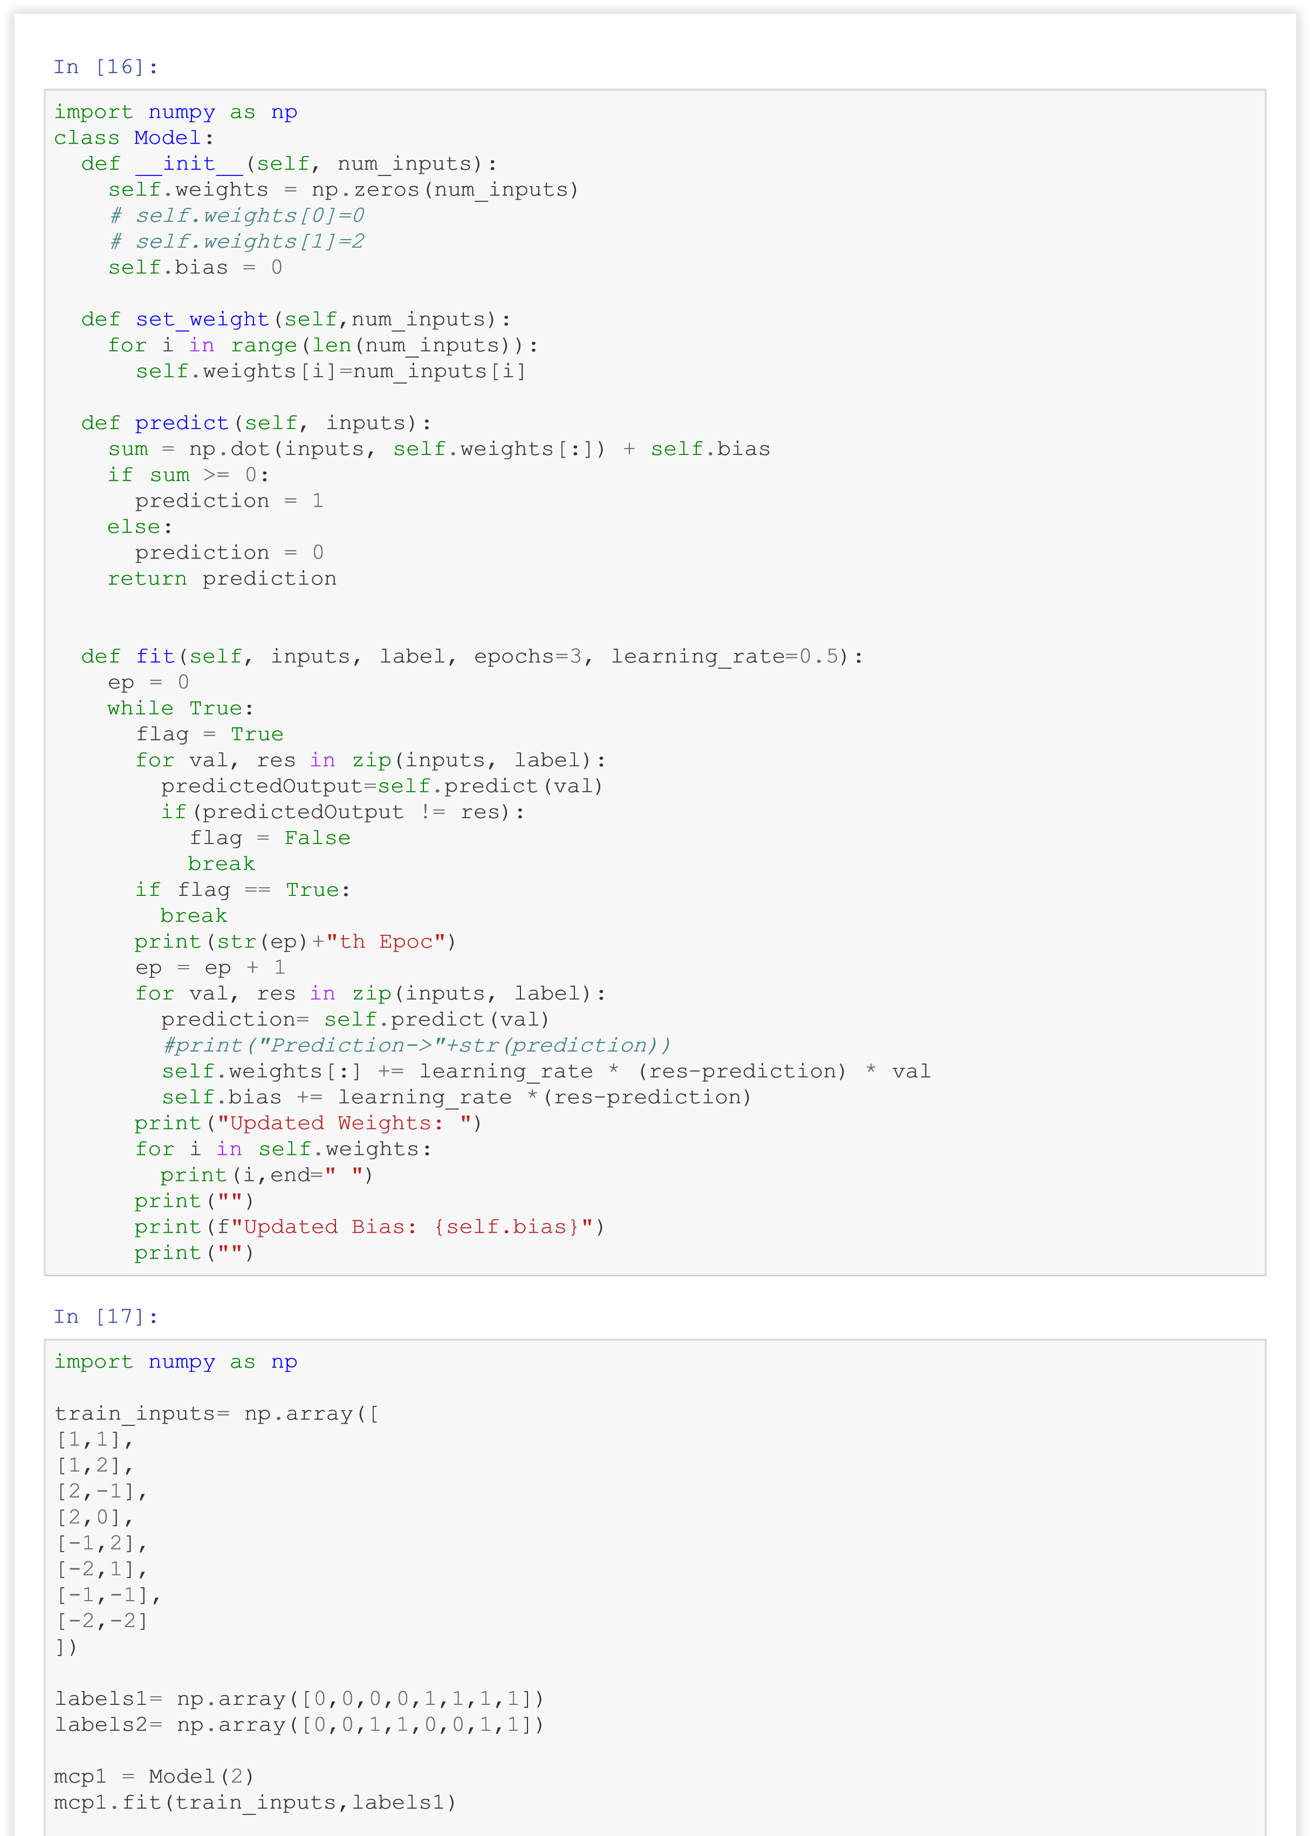



mcp2

=

Model

(

2

)

mcp2

.

fit

(

train_inputs

,

labels2

)

for

inputs

in

train_inputs

:

print

(

inputs

,

end

=

""

)

print

(

mcp1

.

predict

(

inputs

)

,

mcp2

.

predict

(

inputs

))

0

th Epoc

Updated Weights:

-1.0 0.5

Updated Bias: 0.0

1

th Epoc

Updated Weights:

-1.5 -0.5

Updated Bias: -0.5

0

th Epoc

Updated Weights:

0.5 -1.0

Updated Bias: 0.0

[1

1]0

0

[1

2]0

0

[

2 -1]0

1

[2

0]0

1

[-1

2]1

0

[-2

1]1

0

[-1 -1]1 1

[-2 -2]1 1

Ques 2: -

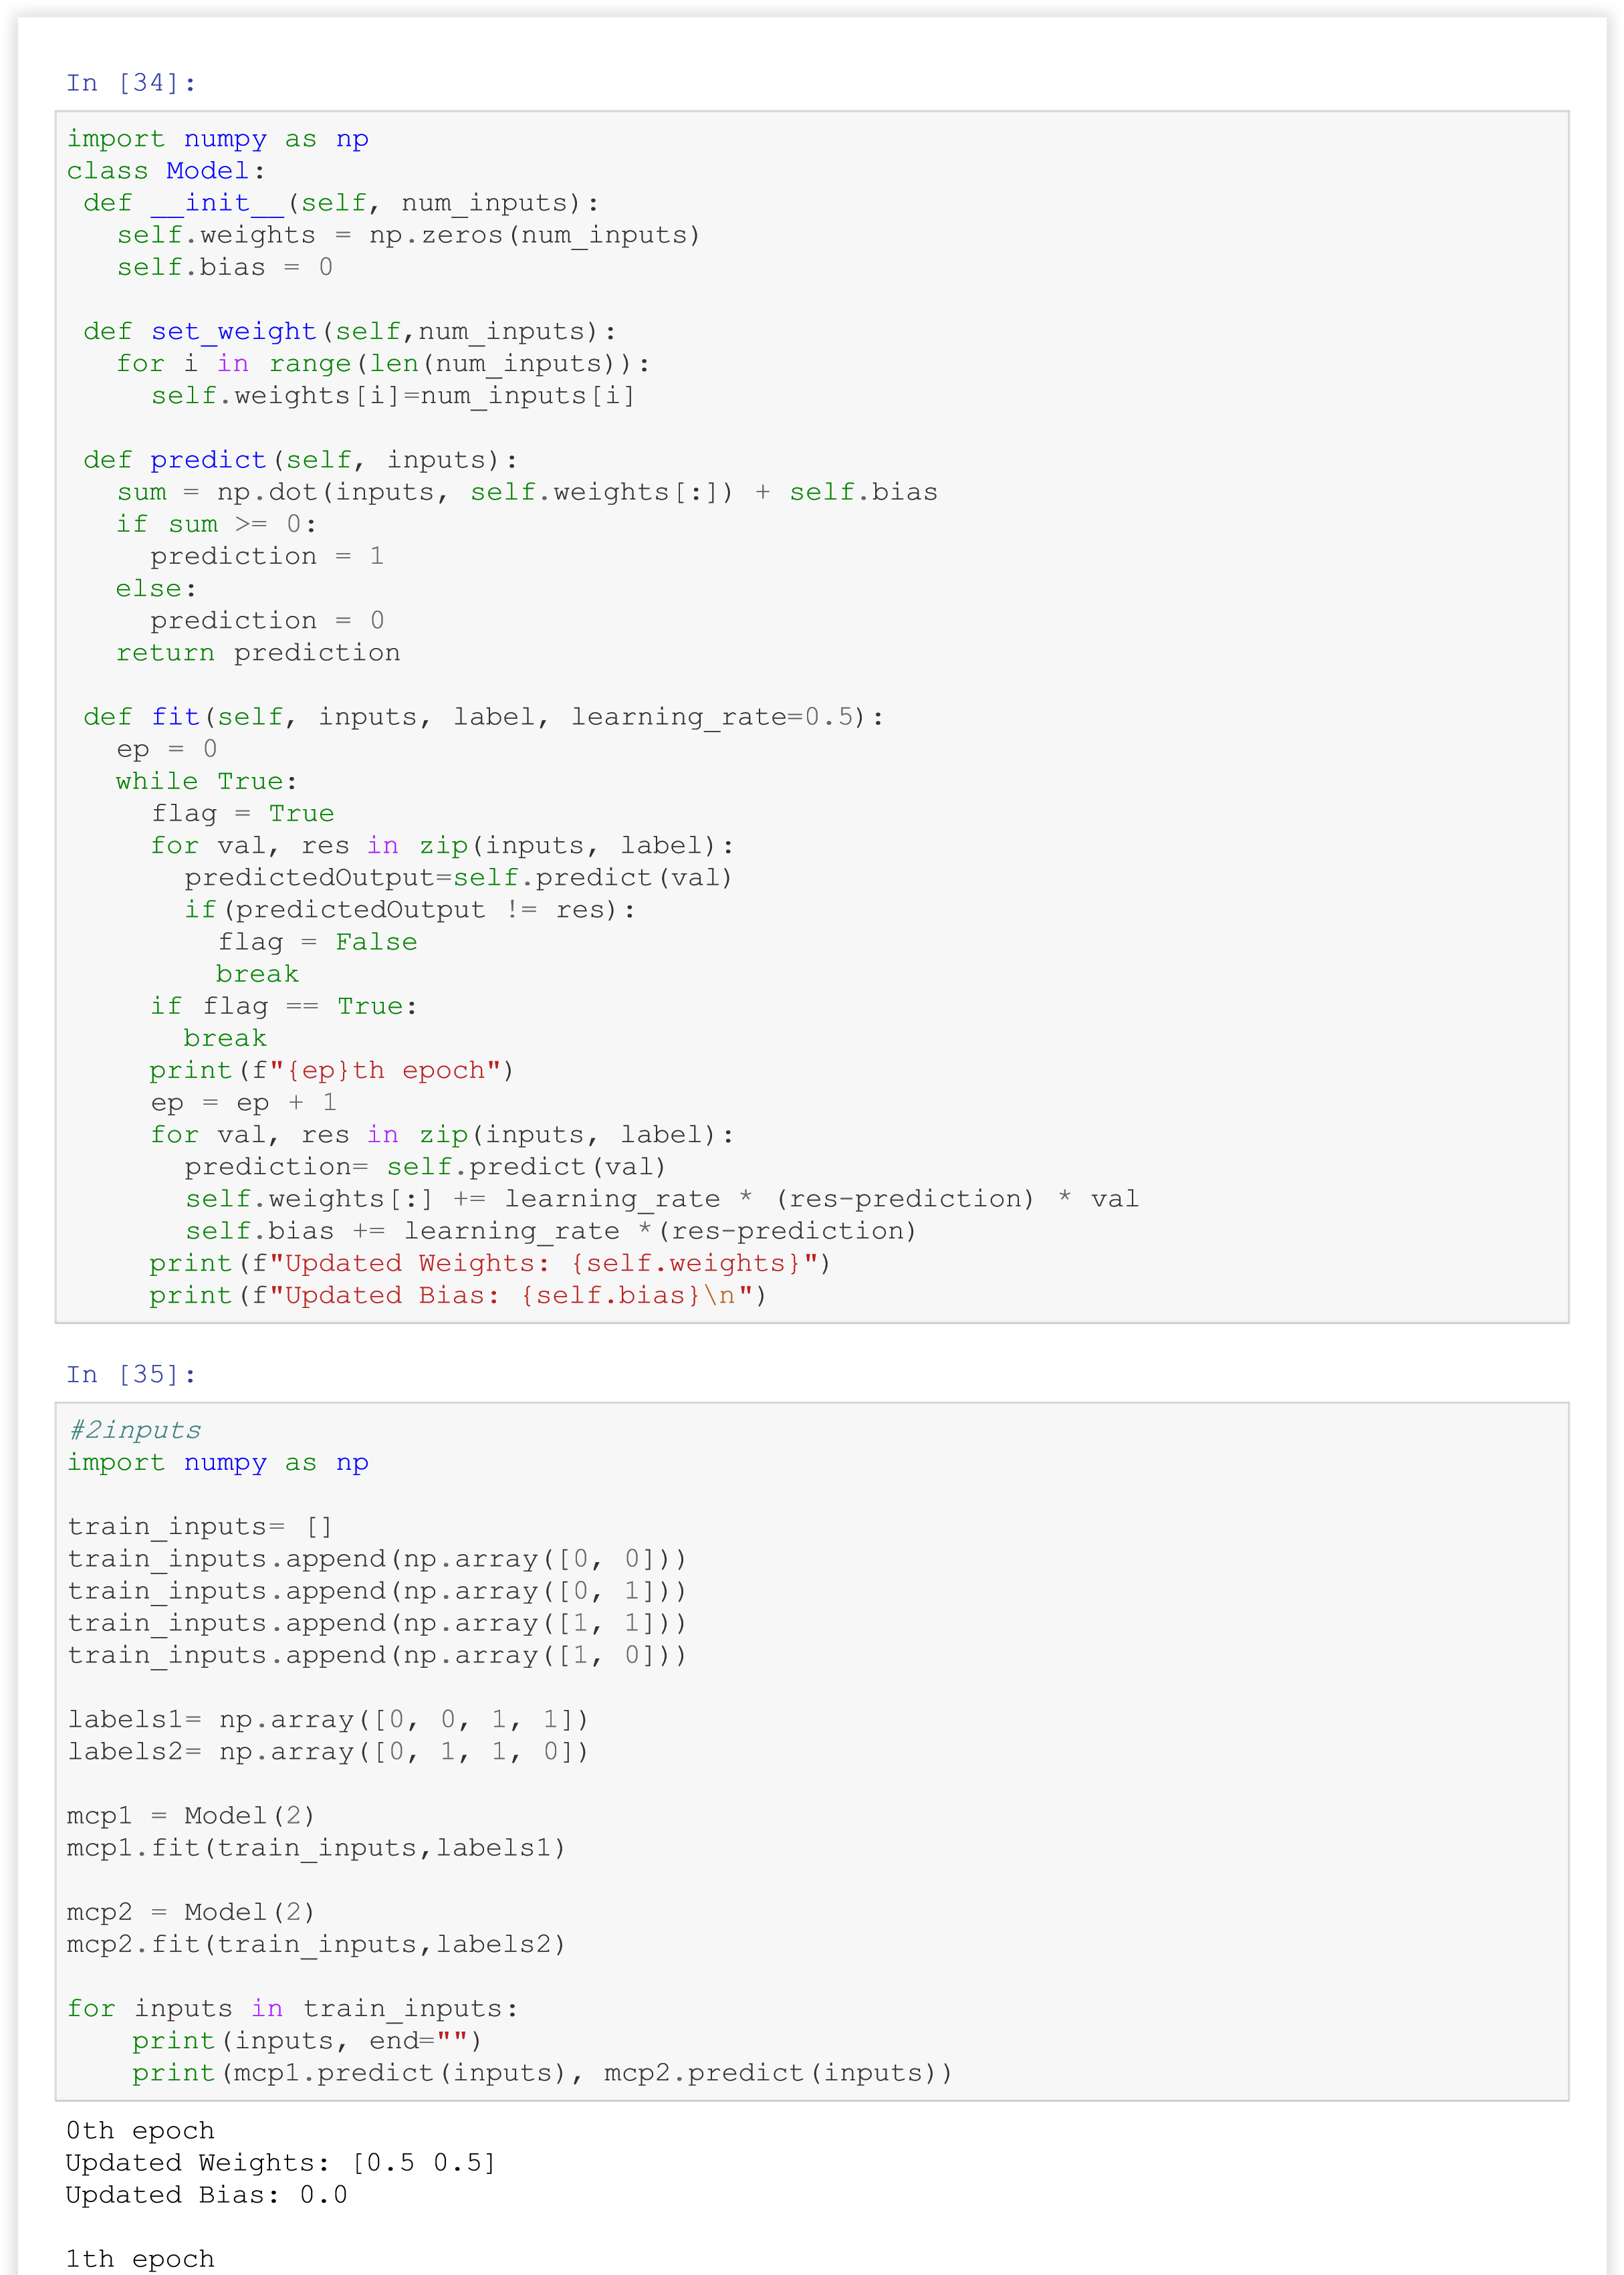

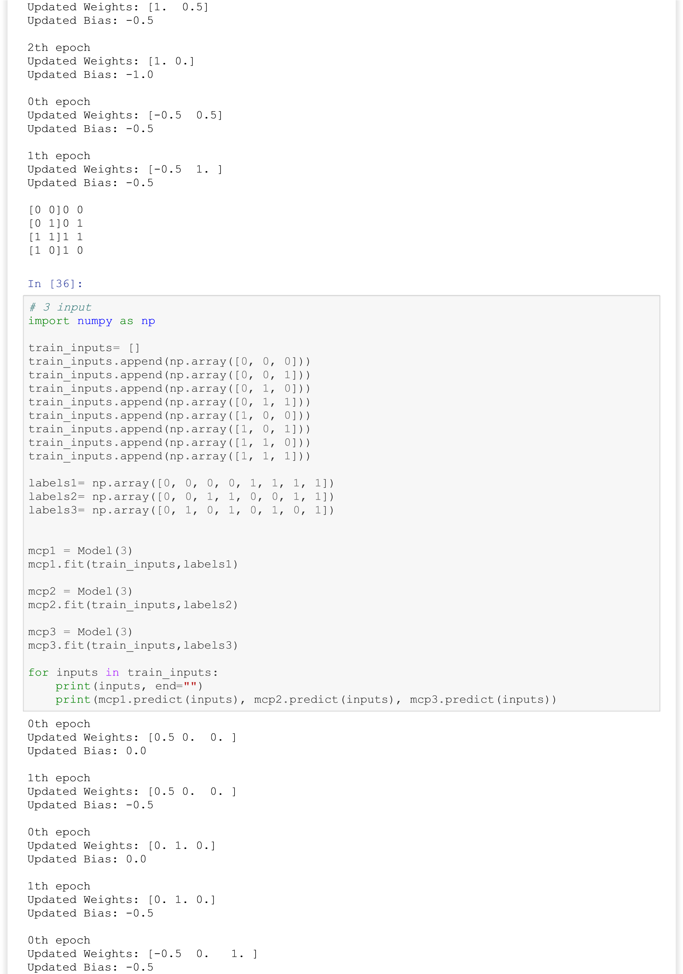



[0

0 0]0 0

0

[0

0 1]0 0

1

[0

1 0]0 1

0

[0

1 1]0 1

1

[1

0 0]1 0

0

[1

0 1]1 0

1

[1

1 0]1 1

0

[1

1 1]1 1

1

# It cannot be done as it is going in infinite loop with 2 or 3 neurons

# Because to classify into 2 classes we have to use another layer which we

# Cannot take

Ques 3: -

